Nama : Raihan Rahmanda Junianto

NIM : 222112303

Kelas : 2KS4

**Responsi Praktikum 13 Pemrograman Berbasis Web**

1. Front-end framework: Bootstrap

* Folder project webbs

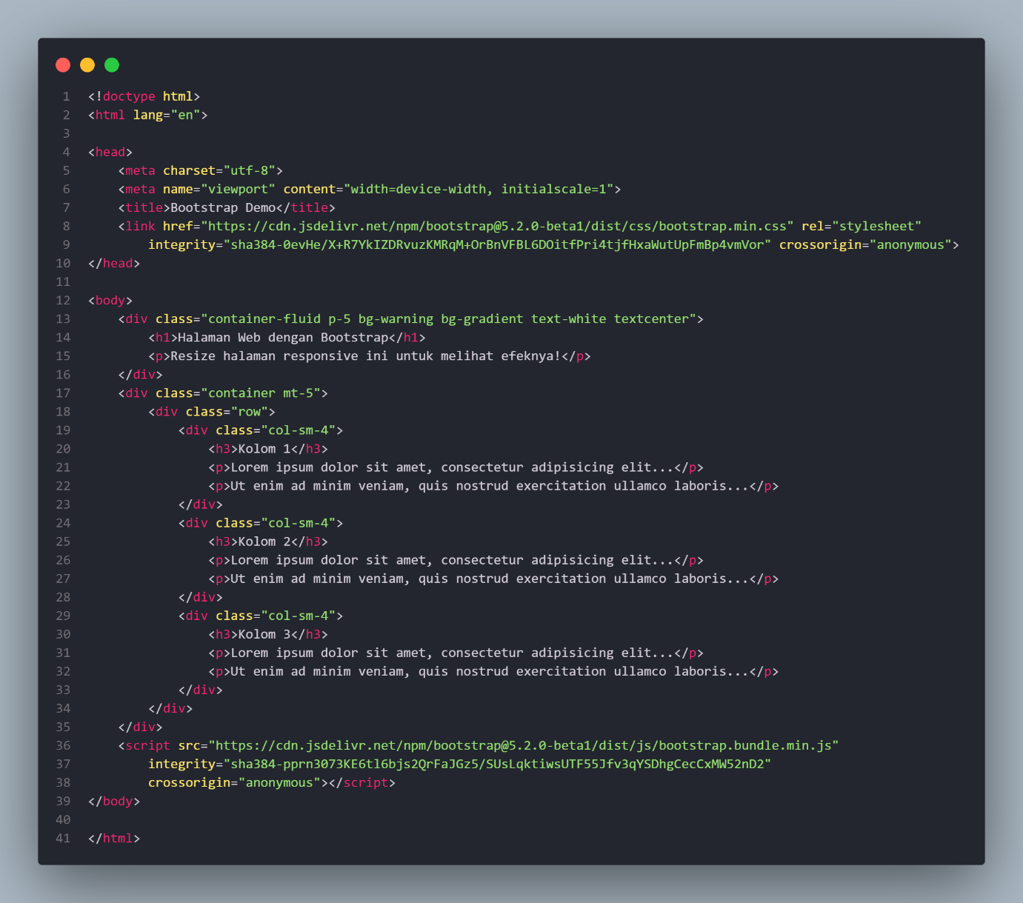

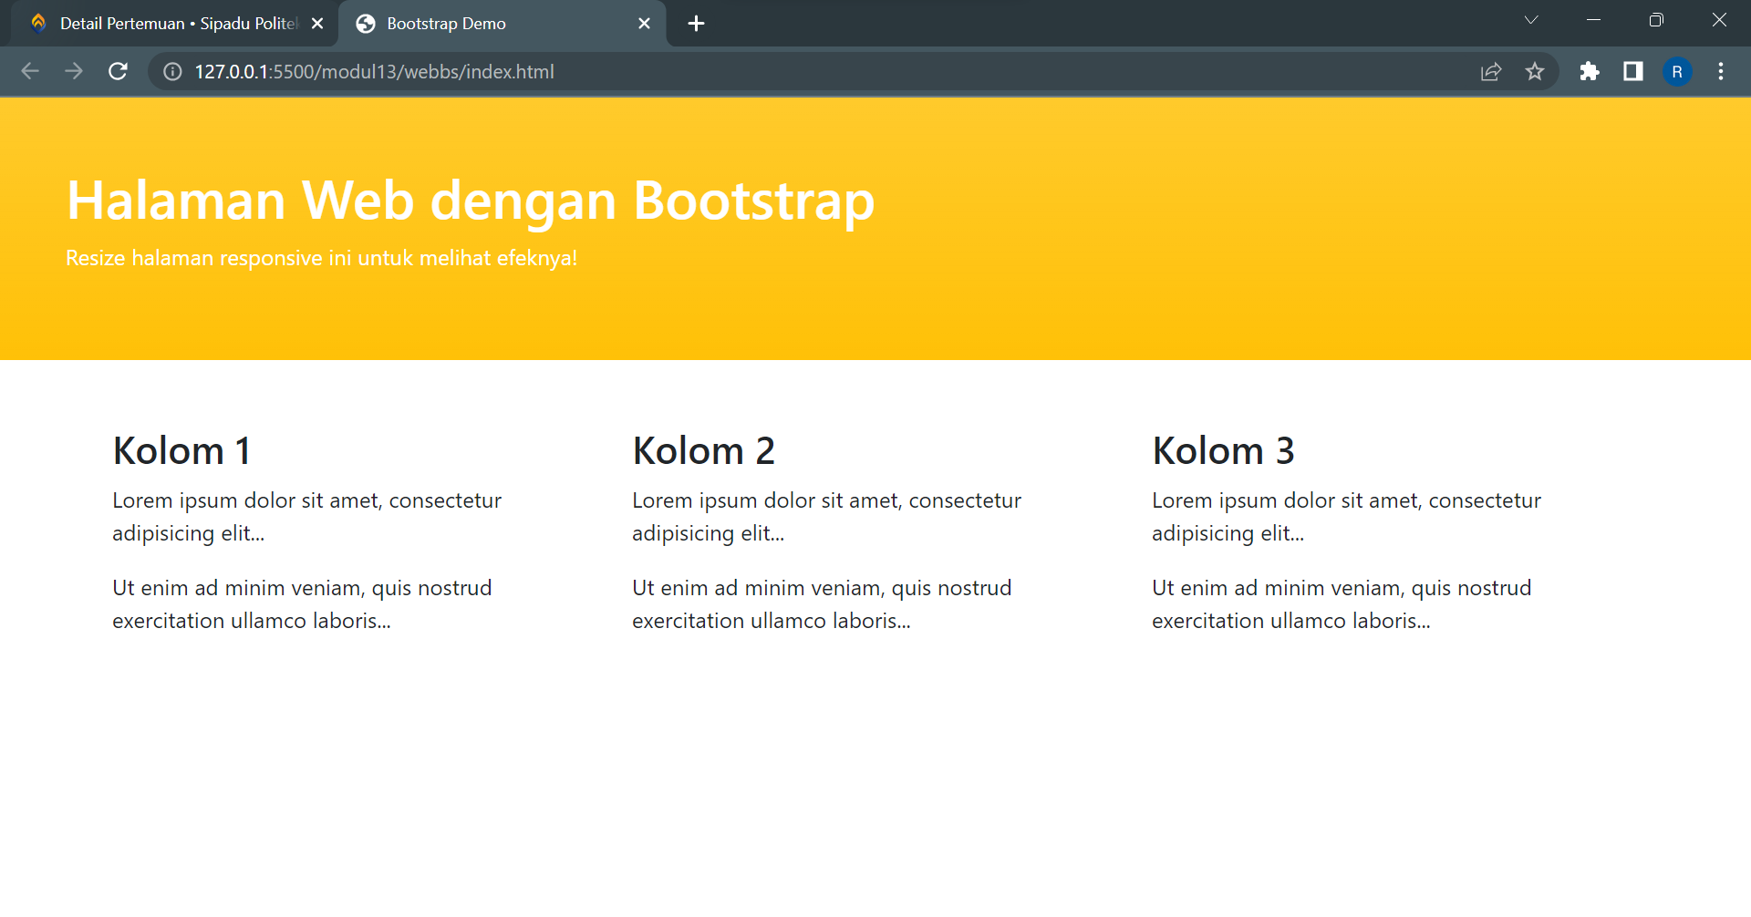

* Folder project webbs_dashboard

Direktori webbs_dashboard

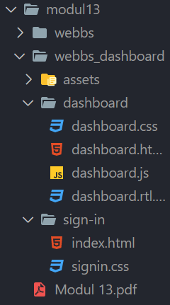

Penambahan pada index.html



Penambahan pada dashboard.html

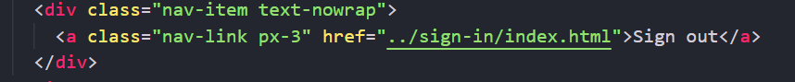

1. Front-end framework: Vue.js

Instalasi Vue.js

Tampilan Vue UI

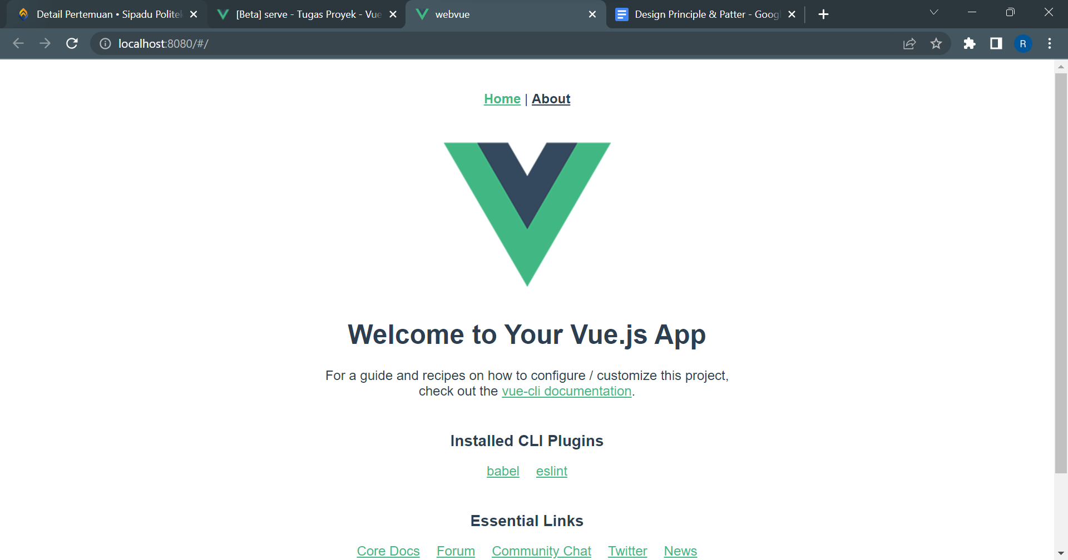

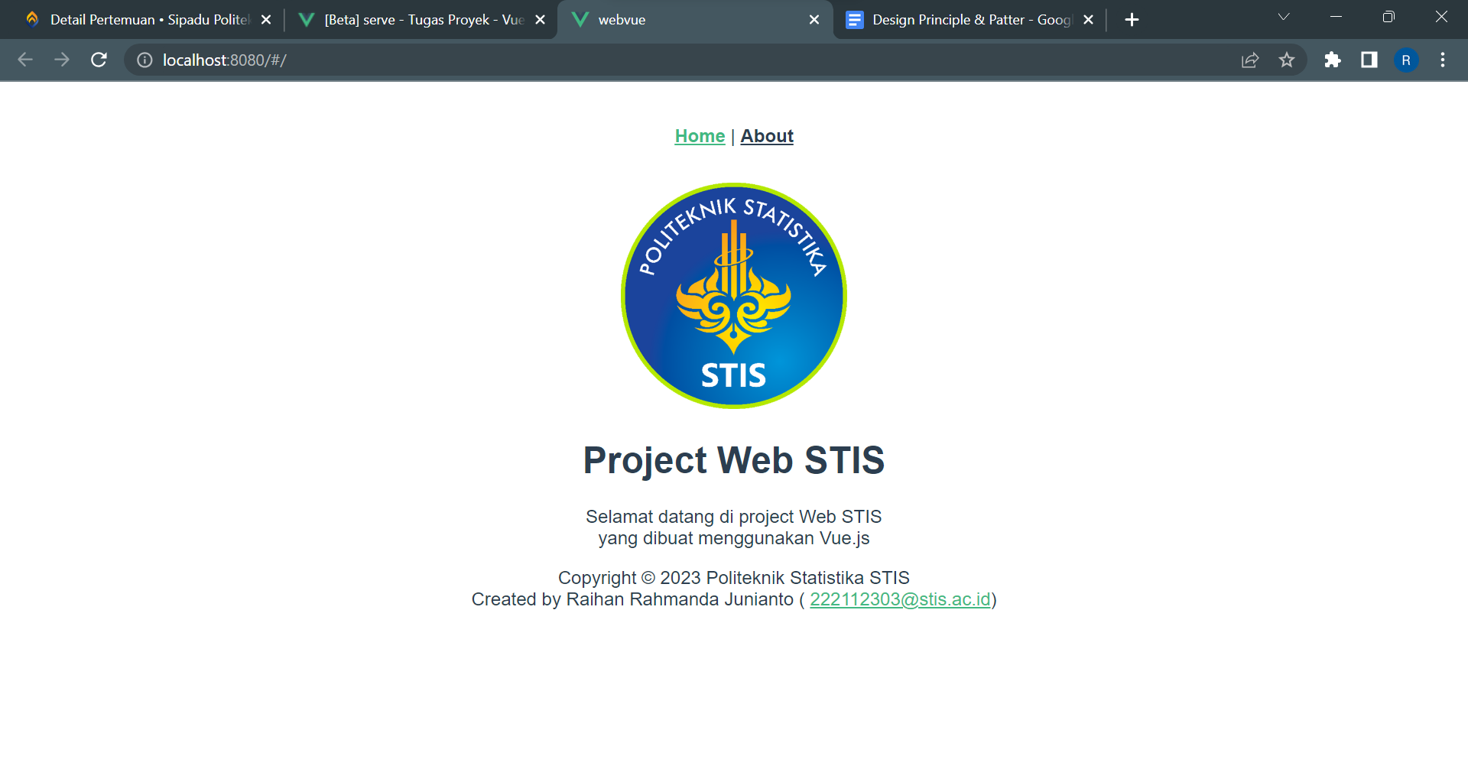

1. Back-end framework: CodeIgniter

Instalasi CodeIgniter

Tampilan footer ketika diganti menjadi development

Tampilan halaman sign in

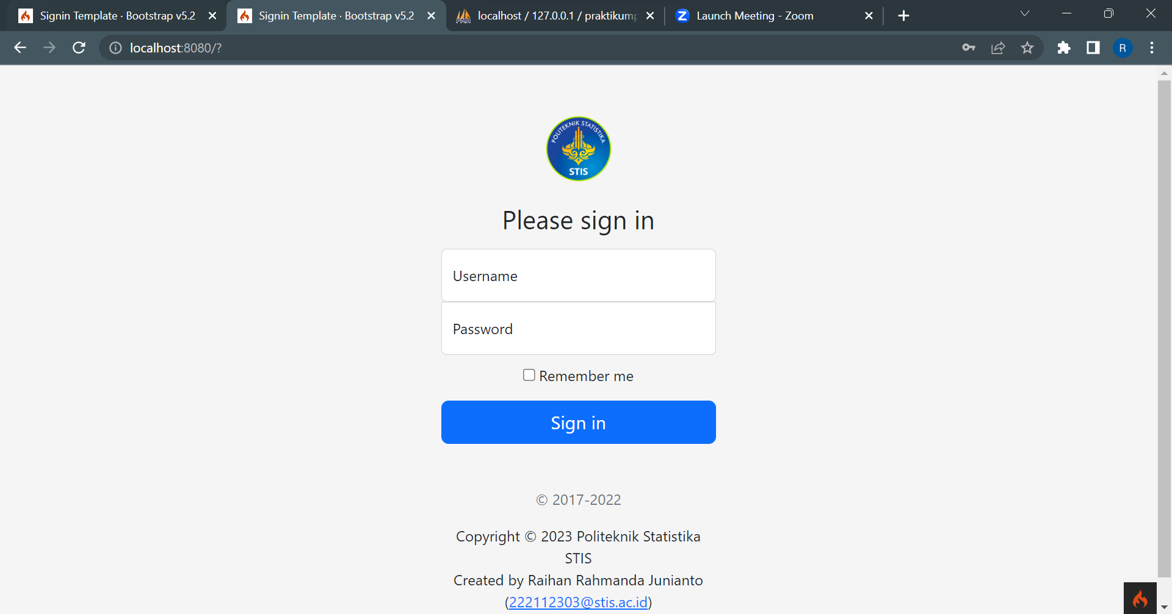

Tampilan ketika berhasil sign in

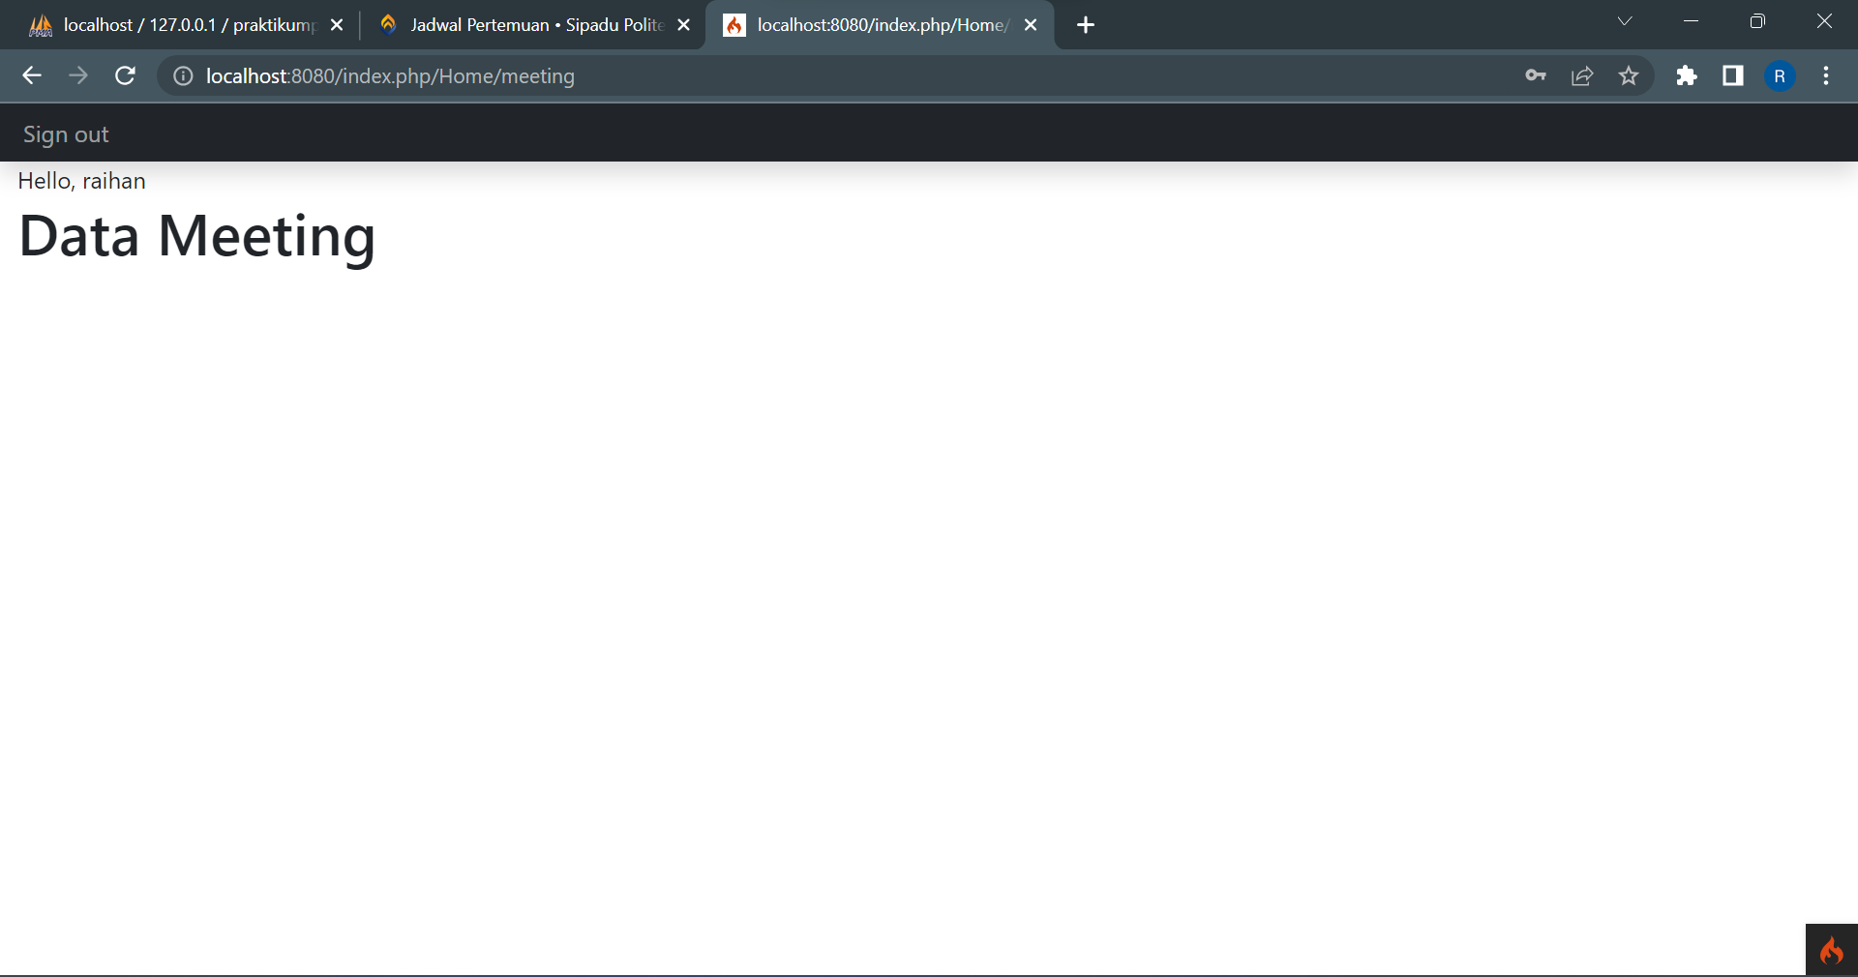

Tabel user di database praktikumpbw

